|  |  |
| --- | --- |
| **TEAMID** | IBM-Project-30638-1660151558 |
| **PROJECTNAME** | IOT BASED SAFETY GADGET FOR CHILD SAFETY MONITORING AND NOTIFICATION |
| **NAME** | VASUNTHARA D |
| **ROLLNO** | 611619205055/319UIT055 |

ASSIGNMENT-1

Create a circuit with piezoalarm,PIRsensor,tmp sensor with below functionalities:

# 1.Alarm should sound in one manner if temp is above 60 C 2.Alarm should sound with another frequency if motion is detected in PIR sensor

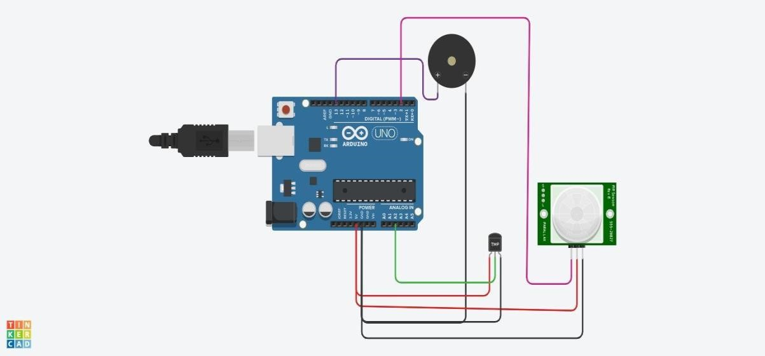CIRCUIT

// C++ code

//

void setup()

{

Serial.begin(9600);

pinMode(2,INPUT);

pinMode(13,OUTPUT);

}

void loop()

{

int motion=digitalRead(2);

Serial.print("Position is");

Serial.println(motion);

if(motion==1){

tone(13,100);

delay(500);

}

else{

noTone(13);

}

double data=analogRead(A2);

double n=data/1024;

double volt=n*5;

double off=volt-0.5;

int temp=off*100;

Serial.print("Temperature is:");

Serial.println(temp);

if(temp>=60){

tone(13,400);

delay(500);

}

else{

noTone(13);

}

}

**OUTPUT:**

